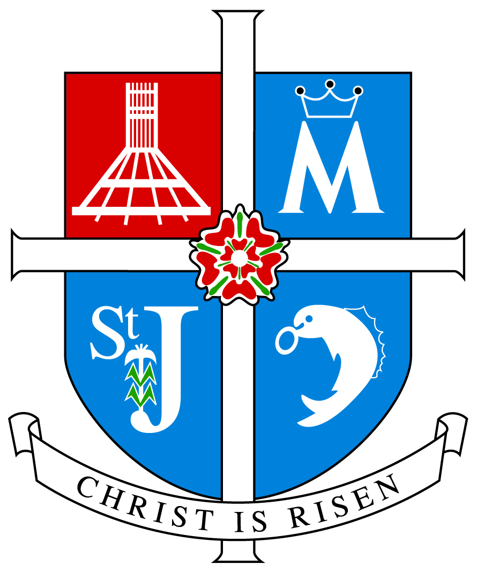

ARCHDIOCESE OF LIVERPOOL

INSPECTION REPORT

ST JOSEPH THE WORKER CATHOLIC PRIMARY SCHOOL

KIRKBY
Inspection Date: Wednesday 16 October 2013

Inspectors Rev D Melly Mr M Halford

Unique Reference Number 131836

Inspection carried out under Section 48 of the Education Acts 2005 and 2011
_________________________________________________________________

Type of School Catholic Primary

Age range of pupils 3 - 11

Number on roll 201

Chair of Governors Mr A McGuinness

Headteacher Miss C Gordon

School address Bewley Drive
Southdene
Kirkby
L32 9PF

Telephone number 0151 477 8173

E-mail address stjosephtheworker.de@knowsley.gov.uk

Date of last inspection 2 February 2010

Introduction

This inspection was carried out under Section 48 of the Education Acts 2005 and 2011

The report of the inspection is produced for the Archbishop of Liverpool (Code of Canon Law 804 and 806) and for the governors of the school.

The inspectors are members of the Christian Education Department and their associates approved by the Archbishop of Liverpool for this purpose.

Information about this school

- St Joseph the Worker school is an average sized Catholic Primary School situated in Kirkby and mainly serving the parish of St Joseph the Worker and St Laurence.
- There are 201 children on roll of whom 175 are baptised Catholic, 15 come from other Christian denominations, and 11 have no religious affiliation.
- There are 12 teachers of whom 11 teach Religious Education and 6 have a suitable qualification in Religious Education. Nine teachers are baptised Catholic.
- Since the last inspection a new Religious Education co-ordinator has been appointed.

Key for inspection grades

Grade 1 Outstanding
Grade 2 Good
Grade 3 Requires Improvement
Grade 4 Inadequate
______________________________________________________________

© 2013 copyright – Archdiocese of Liverpool. This document may be reproduced in whole or in part for non-commercial educational purposes, provided that the information quoted is reproduced without adaptation and the source and date of publication are stated.

Further copies of this report are obtainable from the school.

Overall effectiveness:

St Joseph the Worker is an outstanding school in providing Catholic Education.

Inspection Judgements

The extent to which the pupils contribute to and benefit from the Catholic life of the school.

- The extent to which the pupils contribute to and benefit from the Catholic life of the school is outstanding
- Pupils know and understand the school’s Mission Statement and understand the part they play within it. They are very much involved in its evaluation. Celebration assemblies are always rooted in the Mission Statement and the way the pupils live it out.
- Pupils have an outstanding sense of belonging to the school community and very much respect and value each other. There is a strong sense of collegiality among pupils and staff which enhances the learning process.
- Pupils are encouraged to take on roles of responsibility in the school and wider community. They are members of the school and eco councils. They act as prefects and playground buddies. Older children often help the younger ones.
- Pupils are actively involved in developing the Catholic character of the school as they live out the Mission Statement endeavouring to be a loving Christian family. The respond well to Collective Worship and are taking a greater role in its planning and delivery.
- Pupils have a good sense of right and wrong and apply this in their personal relationships. They take an increasing responsibility for themselves and their actions.
- They praise and acknowledge the contribution of others. They show a readiness to embrace and celebrate their lived experiences.
- Pupils embrace opportunities to meet their potential in all aspects of school life as they strive to achieve excellence.
- Pupils are involved in service to the local faith and religious communities especially as they work with local catechists delivering the ‘With you Always’ Programme. They are heavily involved in the Kirkby Collaborative of Schools where they support the local food bank and also have links with a school in Namibia. They also support the Kirkby Festival. They show respect and understanding of other faiths and religions especially Judaism and Islam. They have also studied Hinduism and Sikhism.

How well pupils achieve and enjoy their learning in Religious Education

- Pupils’ achievements and enjoyment in Religious Education is outstanding.
- Their attainment in Religious Education is outstanding.
- They make outstanding progress in relation to their starting points and capabilities.
- On entry to school many children have a limited knowledge and understanding of the Catholic faith.
- There is no difference in performance between pupils of different gender.
- Outcomes for pupils with additional or special needs are good.
- Analysis of assessments undertaken provides evidence of pupils generally attaining appropriate level for their age and stage of development in each key stage while some exceed.
- Pupils are becoming increasingly more religiously literate. Their knowledge, understanding and skills are developing appropriate to their age or capacity.
- They are developing the skills that enable them to reflect spiritually, think ethically and theologically and are becoming more aware of the demands of religious commitment in everyday life.
- Pupils’ engagement in and enjoyment of their learning is outstanding as shown by their interest, enthusiasm and behaviour.
- Pupils are encouraged to work independently and collaboratively.
- Pupils are anxious to learn and improve their knowledge, understanding and skills as they become independent learners.

How well pupils respond to and participate in Collective Worship

- Pupils’ response to and participation in Collective Worship is Outstanding.
- They show interest, respond enthusiastically and actively participate in Collective Worship.
- They act with reverence and are keen to participate in a variety of gatherings.
- Pupils’ knowledge of prayer and liturgy is increasing.
- They are becoming familiar with a variety of prayer styles. They appreciate and are open to the Word of God in the scriptures which is well proclaimed.
- They reflect in silence and join in community prayers appropriately and with confidence and enthusiasm.
- They are becoming increasingly more confident preparing and leading worship in Key Stage 2.

The quality of teaching and how purposeful learning is in Religious Education

- The quality of teaching and purposeful learning in Religious Education is outstanding.
- It is consistently effective in ensuring that pupils are interested and engaged and make outstanding progress.
- Teachers display excellent subject knowledge and deploy a wide range of teaching styles to motivate and inspire pupils.
- Teaching encourages pupils’ enjoyment of and enthusiasm for Religious Education.
- Teachers obviously took into account pupils’ prior learning and ensured differentiated tasks when planning so that the work on the day consolidated, built on and extended their knowledge and understanding. In the workbooks differentiation was mainly by outcome.
- Teachers provide opportunities for pupils to work independently and collaboratively.
- Excellent use is made of time and resources including other adults, Information and Communication Technology, God’s Story, photographs and Baptismal memorabilia which were brought in from home by both pupils and teachers and a puppet which were all used to maximise learning.
- Pupils are informed of their progress and how to improve both orally and through marking. Some year group books displayed examples of encouragement and dialogue. This needs to become standard practice throughout the school. Effort and achievement are always celebrated.
- The assessment of pupils work in Religious Education is very good
- The school has excellent assessment strategies which provide accurate and detailed information on the achievement of all the pupils.
- Teachers are able to identify how well pupils are achieving and tackle underachievement especially with the support of teaching assistants.
- Teachers are enabling pupils to evaluate their own work.

The extent to which the Religious Education Curriculum promotes pupils’ learning

- The extent to which the Religious Education Curriculum promotes pupils’ learning is outstanding.
- The curriculum is outstanding in meeting pupils’ needs.
- The school, using the Come and See programme recommended by the Archdiocese, meets the requirements of the Curriculum Directory for Religious Education. Appropriate levels of the programme are being followed in different classes. This ensures complete Religious Education entitlement for each child and meets National and Archdiocesan requirements.
- Of the total curriculum time 10% is allocated to Religious Education. This fulfils the requirements of the Bishops of England and Wales.
- Planning ensures full coverage of the Religious Education programme. Imaginative and well planned strategies are deployed to enrich pupils’ learning.
- The school implements new curriculum developments as appropriate.
- Enrichment activities such as the gardening club, violin playing and singing, the film club, and the athletics, football and netball clubs all have a positive impact on the curriculum.
- The Religious Education curriculum provides outstanding opportunities for pupils’ spiritual and moral development and vocation.
- The curriculum is customised to meet the needs of groups and individuals.
- Children have explored the beliefs and values of other faiths and religions. This helps to promote tolerance and respect for those who think differently. This work would be enhanced by inviting speakers from other faiths and religions to the school to talk to the children and by organising visits to other places of worship.

The quality of Collective Worship provided by the school.

- The quality of Collective Worship provided by the school is good with many outstanding features. It reflects the Catholic character of the school and takes into account the variety of faith backgrounds among the pupils.
- Collective Worship has a high profile and is central to the life of the school. A great deal of time and effort has been given to developing Collective Worship since the last inspection.
- Collective Worship plays a key part in meeting the spiritual needs of the pupils. Opportunities are provided to enable full, active and conscious participation of the whole school community.
- Children are enabled to pray formally and informally using a variety of prayer methods and styles.
- The school has provided excellent opportunities for staff to develop the skills in planning, leading and evaluating Collective Worship.
- The teachers are providing the necessary resources and opportunities to help children to develop the skills necessary to plan, lead and participate in Collective Worship and to evaluate it effectively.
- Opportunities are provided for parents, carers the local and wider faith communities to participate in a variety of celebrations of the Come and See programme and the Church’s liturgical year.

How well leaders, governors and managers promote, monitor and evaluate the provision for the Catholic life of the school and plan and implement improvement to outcomes for pupils.

- Leaders, governors and managers are outstanding in promoting, monitoring and evaluating the provision for the Catholic life of the school and in the way they plan and implement improvement to outcomes for pupils.
- This is reflected in the school’s own Mission Statement. All who form part of the school community including parents, clergy, governors and children are involved in the development and review of the Mission Statement each year. Its aims and practical objectives direct and guide every aspect of school life and are a useful tool by which the school can evaluate its effectiveness.
- Leaders, governors and managers are outstanding in the way they use monitoring data to evaluate the schools performance, celebrate, and plan future improvements.
- Outstanding opportunities are provided for the staff and pupils to play an active part in Catholic life and Mission of the school by the way they live out the Mission Statement and the time they give to reflection on inset days and at staff meetings. They know, own and live out their Mission Statement.
- The Self Evaluation Document provides evidence of the schools monitoring, searching analysis and self challenge.
- Their analysis provides a basis to celebrate the school’s strengths and outlining areas for development. The Self Evaluation Document is comprehensive and impacts well on the Catholic life of the school. Areas for development are mainly to be found in the action plan. It was felt that all areas for development need to be incorporated into the Self Evaluation Document.
- The quality of Collective Worship is a priority for the school. It is effectively monitored and evaluated by leaders, governors and managers. An excellent up to date policy is in place.
- Leadership at all levels respects difference, values diversity and ensures equal opportunities for all.
- Prayer, worship and the liturgical life of the school reflects and respects the religious diversity within the school.
- There are positive relationships at every level within the school.
- Parents are consulted regularly and involved in a variety of ways in the life of the school. They receive topic webs which encourage involvement in the Religious Education of their children. They are invited to attend class assemblies, school Masses and school productions.
- Governors are outstanding in fulfilling their responsibilities. They have effectively helped to shape the direction of the school particularly by the time and effort they put into the appointment of all staff to ensure that the Mission Statement is lived out to the full. The governing body is blessed with a wide range of helpful professional experience and expertise. They are totally committed to the school.

How well leaders, governors and managers promote, monitor and evaluate the provision for the Religious Education of the school and plan and implement improvement to outcomes for pupils.

- Leaders, governors and managers are outstanding in promoting monitoring and evaluating the provision for the Religious Education of the school and in the way they plan and implement improvement to outcomes for pupils.
- Monitoring data is used effectively to evaluate the schools performance and plan for future improvements.
- There is a robust programme for the monitoring and evaluation cycle.
- Teaching and learning is monitored regularly and appropriate feedback and support given as necessary. Good practice is shared and celebrated.
- Continuing professional development opportunities are provided for all.
- Assessment information is collated and tracked by the subject leader and shared with the leadership team, governors and parents.
- Formal assessment tasks are undertaken in line with Archdiocesan guidance.
- The subject leader is outstanding in guiding Religious Education. She shows commitment and introduces new initiatives when appropriate. Excellent documentation guides and directs all staff in the delivery of the subject. This is updated as necessary.
- The Action Plan is good in identifying targets, timescales and lines of accountability. This could profitably be incorporated in the Self Evaluation Document.
- Curriculum outlines are provided for parents who are consulted on different issues depending on the topic being covered.
- Achievement and effort are celebrated.

What the school needs to do to improve further?

- Improve provision for Religious Education by:
- implementing the action plan to develop the moderation of assessments;
- implementing the action plan to make more use of the driver words;
- standardisation of marking throughout the school.
- considering inviting speakers of other faiths and religions into the school to talk to the children and organising visits to other places of worship.

INSPECTION JUDGEMENTS

OVERALL EFFECTIVENESS
How effective the school is in providing Catholic Education | 1

OUTCOMES FOR PUPILS
How good outcomes are for individuals and groups of pupils
The extent to which pupils contribute to and benefit from the Catholic Life of the school | 1
How well pupils achieve and enjoy their learning in Religious Education | 1
How well pupils respond to and participate in the school’s  Collective Worship | 1

PROVISION
How effective the provision is for Catholic Education
The quality of teaching and how purposeful learning is in Religious Education | 1
The extent to which the Religious Education curriculum promotes pupils’ learning | 1
The quality of Collective Worship provided by the school | 2

LEADERS AND MANAGERS
How effective leaders, governors and managers are in developing the
Catholic Life of the School
How well leaders, governors and managers promote, monitor and evaluate the provision for the Catholic life of the school and plan and implement improvement to outcomes for pupils | 1
How well leaders, governors and managers monitor and evaluate the provision for Religious Education and plan and implement improvement to outcomes for pupils | 1

Key to judgements: Grade 1 is outstanding, Grade 2 good, Grade 3 requires improvement and Grade 4 inadequate

